Electronic prosthetic arm

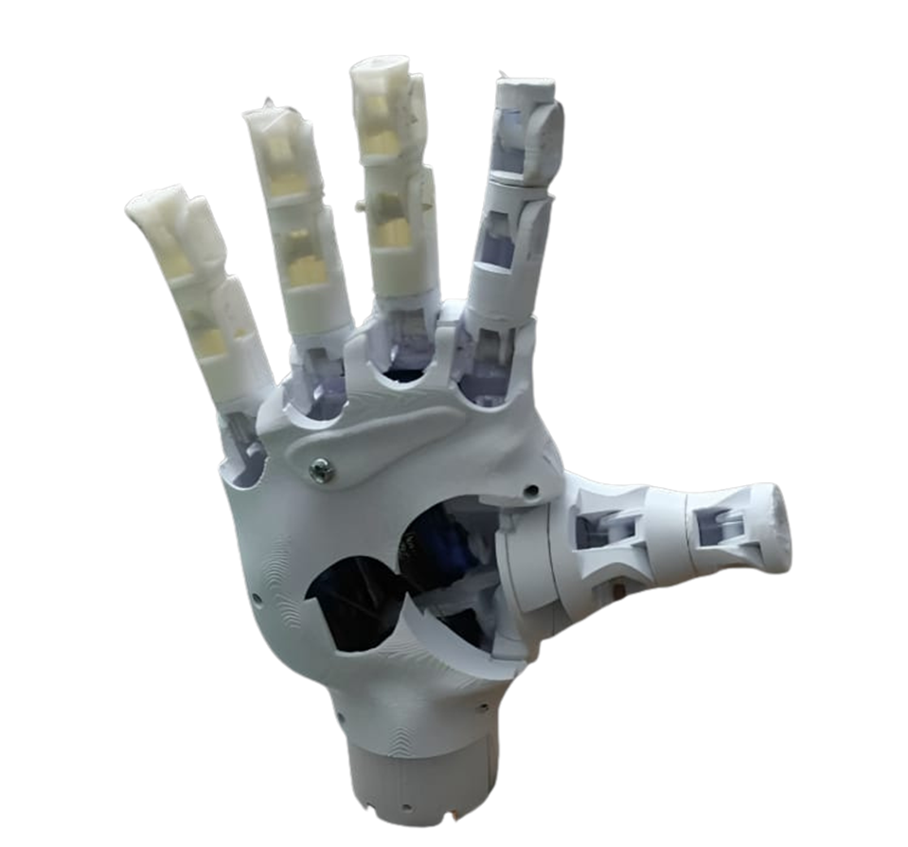

**Submitted By**

**Samy Gerges Samy 20203238 Islam Sobhy Soliman 20190181 Mohamed Saad Fathy 20203139 Gaser Tarek Helmy 20190246 Ibrahim EL- Sayed Zanoun 20203127 Nashaat Baher Mohamed 201611033**

# SUBMITTED TO

DR/ Ghada Kareem

# Head Of the Department

Prof/DR/ Amal

**What is the objective of the project ?**

The goal of the smart prosthetic limb project is to improve the quality of life for individuals who have lost their limbs by providing innovative technological solutions that enable them to regain the ability to move and control naturally. This prosthetic limb relies on muscle signals, allowing users precise control and smooth movements that resemble natural.